A.C.E.D PROJECT | Automatic Chicken  Enclosure Door
Automatic Chicken’s proposal for project initiation of the automated chicken enclosure door in the first quarter of 2015. Included herein are the milestones, the vision, and the overall goals of the Automatic Chicken design group. |  | John Lin  Mike Andrews  Brandon Khong  Nathan Ehrenholz
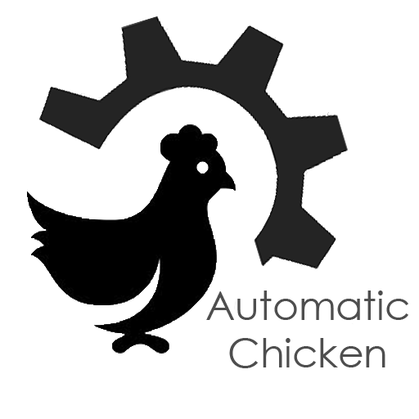

Table of Contents
1 Biographies 3
2 Executive Summary 3
3 Goals and Objectives 3
3.1 Vision Statement 3
3.2 Problem Statement 4
3.3 Objectives 4
4 Definitions and Acronyms 4
5 Technical Approach 4
5.1 Design Evaluation 4
5.2 Structure 5
5.3 Mechanics 5
5.4 Electrical 6
5.5 Software 6
5.6 Safety 6
6 Milestone List 7
7 Schedule Baseline and Work Breakdown Structure 7
8 Roles and Responsibilities 7
8.1 Production Manager 7
8.2 Materials Specialist 8
8.3 Software Engineer, Editor 8
8.4 Production Engineer 8
9 References 8
10 Appendix A: Schedule & Deliverables 9
10.1 Gantt Chart 9
11 Appendix B 10
11.1 WBS Dictionary 10

List of Figures
Figure 1: Door Track 6
Figure 2: Door Seal 6
Figure 3: Door Roller 6
Figure 4: Homemade auto chicken coop door 6
Figure 5: Arduino Flowchart 7
Figure 6: Gantt Chart 10

List of Tables
Table 1: Major Milestones 8
Table 4:WBS Dictionary 11

Biographies

John Lin
A second year MSE student, fascinated by physics and mechanical design.

Brandon Khong
A first year MSE student who is enthralled with inventing useful devices.

Mike Andrews
A second year MSE student, experienced in the electrical trade and always enthusiastic to undertake any new integrated mechanical and software project.

Nathan Ehrenholz
A third year MSE student. Now living as a semi retired Millwright / Machinist / Refrigeration Technician whose hobbies include backyard chicken farming.

Definitions and Acronyms
A.C.E.D Automated Chicken Enclosure Door
Arduino Programmable Microchip
PPE Personal Protective Equipment

Executive Summary

For AUTOMATIC CHICKEN’s next real world solution, an automatic chicken enclosure door has been decided upon. For the A.C.E.D. Project, the door will be of a roll up design, constructed on as many donated parts as possible. An Arduino will be the brains of operation, coupled with a smoke detector and a pair of photo resistors for automatic and safe operation. The muscle will be a 12VDC re-purposed automotive window motor. The door will recharged with a solar panel every day. As a reserve, 120VAC will also be able to power the door for the dark months of northern winters.
The project encompasses many different aspects of engineering: structural, mechanical, electrical, and software. AUTOMATIC CHICKEN will employ the team members with the least skills in each area to encourage the most experience and growth.

While automated pet door technology is currently available, AUTOMATIC CHICKEN believes that we can really “leave the roost” in ways never before imagined.

Goals and Objectives

Vision Statement
To create a Gallus Gallus Domesticus enclosure gate which is automatically actuated and solar photovoltaic powered for the betterment of both chicken and man.

Problem Statement
Chicken coops must be opened every morning to give the chickens light, and allow them to exercise and run free. This helps to ensure that the hens are in the best condition to produce an optimal amount of eggs, and helps to keep them generally healthy. This task is made difficult because many people have busy schedules and have a hard time waking up at sunrise every morning to let their chickens out of the coop, which keeps the chickens locked in darkness for an undue amount of time and decreases both their productivity and their general health.

The coop must be kept closed at night to protect the chickens from outside threats, such as inclement weather and wild animals. The door mechanism must not create any danger or risk to the chickens or the coop itself, nor should it produce any waste products or undue noise, and the operation and maintenance of the door must not increase the workload of the customer.

Objectives
To overcome these problems, we will design an automated solar powered chicken coop door. Having an automated door would mean having wires, gears, and other devices inside the chicken coop, which could put the chickens at risk. To get around this, we plan to create a protective cover that is both solid and weatherproof. Proper wire sizes and protective devices will be used to mitigate the risk of fire, and the door will be interfaced with a smoke detector that will cause the coop door to automatically open in an emergency.

Our goal is to have a prototype operational by the end of the first quarter (end of April 2015) to satisfy our customer’s needs, and to come in under the budget as laid out by our client.

Technical Approach

Design Evaluation
The reason that the roll-up design has been chosen is based on reliability and ease of use compared to a swing out design, which also greatly reduces the risk of having the door become stuck on an accumulation of bedding and excrement. Furthermore, most chicken coops are built with a high roof, but often they would have no room for a door to swing open, revealing that a roll up design is a more universal approach and will be compatible with the chicken coops of a much wider customer base.
Figure 1: Door Track


Structure
To facilitate both the rigidity of the structure and the smooth operation of the roll up door, Whiting roller door track has been selected to serve as both the track and frame. The track is made of heavy duty galvanized steel and formed to be used with roller bearing wheels. A side seal is also readily available to help keep drafts and vermin to a minimum. Because of the steel construction, the prototype will be simple to produce and allow for us to weld on brackets and structural supports with ease.

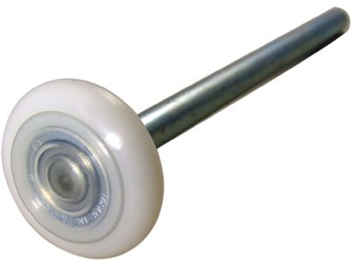
The door is designed to use a laminated steel-plastic-steel design to increase durability,
cosmetics, and reduce size. A seal will be
added to the top to reduce drafts, and brackets
to accommodate the rollers and cables.
Figure 2: Door Seal
Figure 3: Door Roller

Mechanics
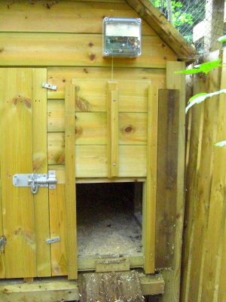
The mechanics have been meticulously planned and designed to ensure reliability and also to maintain high standards of quality. The coop door functions by sliding up to allow chickens to exit when both the front and back photo resistors detect light. Our product will resemble the one shown in Figure 4, but with the inclusion of a great many innovations and design improvements.
Figure 4: Homemade auto chicken coop door (Louisa, 2010)

The frame of the door will be made of galvanized steel instead of wood. A single cable will be attached to the top of the door in order for the door to be raised, with the help of a double pivot. The cable is then wound around a spool by a re-purposed automotive window motor to raise the door, with the motor running in reverse to lower the door.
When the door is raised, it is of utmost importance that the door stays up and does not come crashing down due to inferior
construction materials. Stainless steel aircraft cable will be used to ensure that the door is firm and securely in place as the chickens exit the coop. Aircraft cable is widely used in the aircraft industry and in many military applications, and it is also commonly used in commercial settings as well. Its high tensile strength makes it a suitable building material for this project.

Electrical
In the design of the circuitry of this project, the correct use of electrical components is critical, as any errors could eventually become a fire hazard. A general circuit diagram will be created by our team of experts, making it possible to select the correct parts, such as resistors and transistors, and to calculate the correct wire gauges.

Software
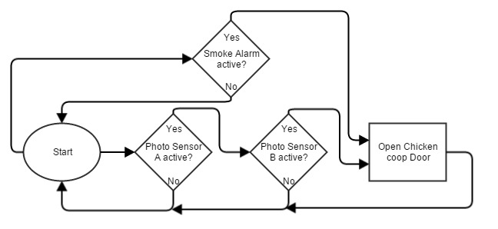
The Arduino microcontroller will be used to control the motor, based on input from two light sensors and one smoke detector. Both light sensors will need to be active to signal the microcontroller to open the door, but for safety reasons the smoke detector will bypass any other controls once smoke is detected.
Figure 5: Arduino Flowchart (Andrews, 2015)

Safety

The personal safety of the team is of the utmost importance at AUTOMATIC CHICKEN. It will be required for all team members to wear proper PPE at all times when handling tools. Each team member is to understand the nature of any electrical components prior to working with them to avoid harm to personnel or equipment.
Before any work is done the team will perform a pre-task assessment. The proper safety procedure needs a 100% agreement of all parties involved in the work before implementation and proceeding with the work in question.
If any injuries occur proper first aid must be administered by a qualified individual, and the injured party must immediately be taken to the appropriate medical facility as necessitated by the severity of the injury.
During the design phase, the safety of the end user and the chicken is to be the most important deciding factor. Safety features are to be added to the device to parallel AUTOMATIC CHICKEN’s view on safety.

Milestone List

Table 1: Major Milestones
Milestone | Description | Date
Poster | Submit Poster by the beginning of the lecture (8:30pm) | 4/1/2015
Preliminary System Design | Agreed upon basic design for the prototype | 2/1/2015
Testing | In class testing of the finished dynamic system | 3/27/2015
Completion | Final report and working dynamic system due by the start of lecture (8:30am) | 4/1/2015
Power Point | 5 Slide Power Point | 2/27/2015

Schedule Baseline and Work Breakdown Structure

AUTOMATIC CHICKEN has developed the WBS for the A.C.E.D. Project collectively as a team based on each team member’s strengths and weaknesses and the deliverable’s requirements. The WBS has three main work packages; hardware, electrical, and software. Within these three work packages are several tasks which are defined and assigned to a team member in the WBS Dictionary in Appendix B.
After determining the main work groups and the respective sub-categories, the A.C.E.D. Project schedule, Gantt chart in Appendix A, was developed. The schedule will be adhered to as best as possible and will be reviewed at every general meeting. If any sub-category has fallen behind, the team must focus available resources on that work package and sub-category to diagnose and problem solve so as to help keep the project smoothly moving forward.
For specific timelines, see the Gantt chart in Appendix: A.

Roles and Responsibilities

AUTOMATIC CHICKEN has adopted a bottom-up organizational structure, thus responsibilities and required deliverables will be dynamic and decided upon at the weekly general meetings. The specific deliverables that each team member will be held accountable for are listed in the WBS Dictionary in Appendix B, and the overview of each team member’s responsibilities are as follows:

Production Manager
(John Lin) – The Production Manager is responsible for the design and procurement of the electrical components for the A.C.E.D Project. He is therefore, responsible for understanding the risks to the electrical equipment and implementing the proper procedures to keep both body and equipment safe. For specific deliverables please refer to the WBS Dictionary in Appendix B.

Materials Specialist
(Brandon Khong) – The Materials Specialist is wholly responsible for the acceptance of materials for construction of the A.C.E.D Project. He is to oversee the design evaluation and must give approval of materials prior to their procurement. The Materials Specialist will also aid the Production Engineer in the construction of the mechanical structure. For specific deliverables please refer to the WBS Dictionary in Appendix B.

Software Engineer, Editor
(Quillan Mike Andrews) – The Software Engineer will be responsible for all the coding and programming requirements for the A.C.E.D Project using the Arduino microcontroller. Furthermore, The Software Engineer will be responsible to the final edits to submitted documentation, power points, and posters. For specific deliverables please refer to the WBS Dictionary in Appendix B.

Production Engineer
(Nathan Ehrenholz) – The Production engineer will be responsible for the procurement of most hardware materials for the A.C.E.D. Project. He will be tasked with constructing the basic frame of the chicken door and ensure that testing of the final deliverable is up to AUTOMATIC CHICKEN’s standards. He will produce a report near the completion of the prototype to investigate effect of solar panel production. For specific deliverables please refer to the WBS Dictionary in Appendix B.

References

- Arduino. (n.d.). Getting Started with Arduino. Retrieved from http://arduino.cc/en/Guide/HomePage
- Louisa. (2010). Automatic Chicken Coop Door [Online Image]. Retrieved February 18, 2015 from http://www.thereallygoodlife.com/554/automatic-chicken-coop-door/
- Devanco Canada. Truck Door 2” Vertical Track with Holes 95.00” Long for Whiting Roll-Up Doors. Retrieved February 18, 2015 from http://www.devancocanada.com/products/search/manufacturer:52/category:100/sub_category:580/subsubcategory:1010
- Devanco Canada. Whiting Side Seal Option for Dry Freight Door. Retrieved February 18, 2015 from http://www.devancocanada.com/product/510.5377.00
- Amazon Canada. 2 inch 13 Ball Nylon Garage Door Roller (7 Inch Stem). Retrieved February 18, 2015 from http://www.amazon.com/10-2-Inch-Nylon-Garage-Roller/dp/B004HIXBMK
- Andrews, M. (Photograph). (2015, February). Arduino Flowchart[photograph]. Vancouver.

Appendix A: Schedule & Deliverables

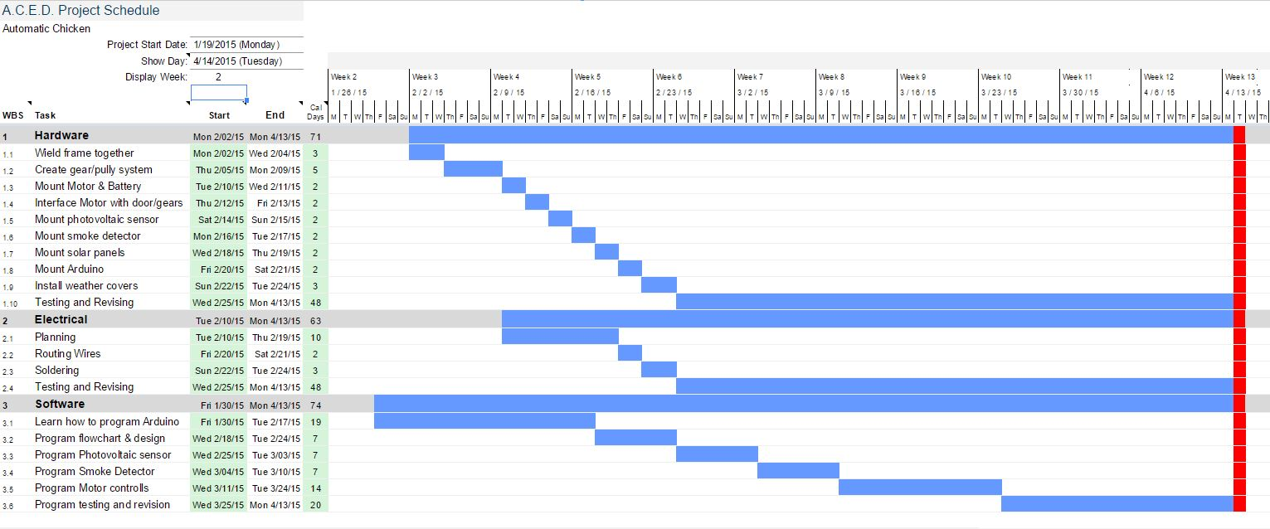
Gantt Chart
Figure 6: Gantt Chart

Appendix B

WBS Dictionary
Table 2:WBS Dictionary
Level | Code | Element Name | Definition | Member
3 | 1 | Hardware | Procedures for putting together the coop door.
3 | 1.1 | Weld Frame Together | Welding and putting together the frame for the door to slide up and down | Nathan
3 | 1.2 | Create gear/pulley system | Creating gears and pulley for pulling the door up. | Nathan
3 | 1.3 | Mount Motor & Battery | Connecting the motor and battery to the pulley system and mounting it in a safe place. | Brandon
2 | 1.4 | Interface Motor with door/gears | Coordinating the motor with the door/gears. | Nathan
3 | 1.5 | Mount photovoltaic sensor | Placing the photovoltaic sensor where light can be detected and connecting it to the microcontroller. | Brandon
3 | 1.6 | Mount smoke detector | Placing the smoke detector inside the coop where it can detect smoke. | Brandon
2 | 1.7 | Mount solar panel | Mounting the solar panel on the roof of the coop | Nathan
2 | 1.8 | Mount Arduino | Arduino is mounted at a safe place where it is accessible to all sensors and electronics. | Brandon
2 | 1.9 | Install weather covers | Weather covers are installed to protect the coop door and sensors. | Nathan
3 | 1.10 | Testing and reviewing | The mechanical structure is tested. | Brandon
3 | 2.0 | Electrical | Procedures for electrical and wiring.
2 | 2.1 | Planning | Planning the wiring and routing process. | Mike
3 | 2.2 | Testing | Testing if the wiring works. | John
3 | 2.3 | Routing Wires | Organizing and routing the wires to prevent a messy look. | John
2 | 2.4 | Soldering | Soldering the wires to circuit boards and electronics | John
3 | 2.5 | Testing & Revising | Testing the overall wiring to see if everything functions properly. | Mike
3 | 3.0 | Software | Designing the software to achieve all the required tasks.
1 | 3.1 | Learn how to program Arduino | Familiarizing ourselves with the Arduino programming language. | Mike
2 | 3.2 | Program flowchart & design | Mapping the design of the program | Mike
3 | 3.3 | Program Photovoltaic sensor | Programing the sensor to execute tasks when it senses light. | Nathan
3 | 3.4 | Program Smoke Detector | Programming the smoke detector to execute tasks when it senses smoke. | Mike
3 | 3.5 | Program motor controls | Programming the motor to function accordingly. | Mike
3 | 3.6 | Program testing and revision | Testing the program to see if it functions correctly. | Mike

